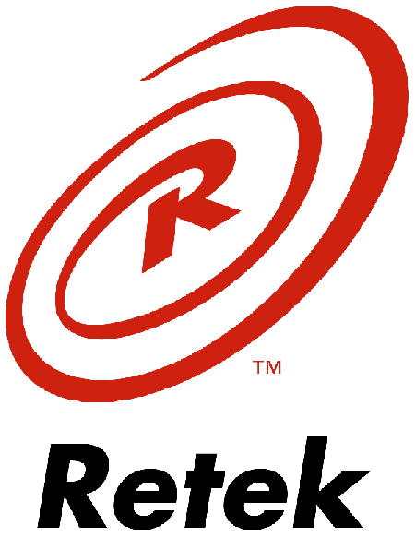

Retek Distribution Management
Release Notes
10.1

Retek Distribution Management (RDM) 10.1

RDM Functional Enhancements
Retek Distribution Management 10.1 provides best-practice support for advanced warehouse and Distribution Center (DC) operations for retail. There have been enhancements in the following areas:
- Optimization within Execution
- Flexible Supply Chain Foundation

Optimization Within Execution

Forward Picking Location Enhancements
Several enhancements have been made to provide greater flexibility in the determination, management, and fulfillment of Forward Picking Locations:

Top Off Replenishment
Top off replenishment provides RDM users with the ability to fill forward pick locations to capacity without a replenishment having been triggered by wave demand or the location reorder point. Environments with forward picking locations find top off replenishment useful for preparing locations in off times before picking activities.
A process in RDM evaluates the inventory and existing inbound replenishments for a user defined list of locations to determine where bulk or case top off replenishments should be created to fill the locations to capacity.

Dynamic Overflow
The capacity of a forward picking location is defined in RDM by setting the total number of units for a specified item that can fit in the location. Currently, preplanned replenishment will overfill locations by sending a quantity of merchandise to a picking location that will fill the unit capacity plus meet demand for the current wave. This leaves the location full after the wave has been completely picked. However, in some environments this can create operational issues because space constraints prevent overfilling of locations.
Dynamic overflow provides the ability to define locations with a hard limit on capacity, and when the capacity limit would be exceeded it will provide an overflow area for items to be directed to and picked. This gives operators in an environment with constrained locations the ability to manage forward picking locations during unanticipated volume peaks.
Overflow locations differ from random locations because items in the overflow area will have a forward picking location defined. Overflow locations are created as a temporary forward picking location to handle a spike in volume that cannot be handled by the existing forward pick location.

Forward Picking Location Cleanup

Inventory slotting in the warehouse can require a significant amount of maintenance when there are a large numbers of SKUs/items required in forward picking locations (also know as active picking locations). Proper slotting techniques are a key to an efficient warehouse, and any opportunities to reduce the maintenance involved can help increase in the overall productivity of the warehouse operations. The objective of this requirement is to assist RDM users with a configurable automated process for freeing up valuable forward picking locations.

There are also opportunities to consolidate forward picking locations which will also free up locations. RDM provides a “rules based” process for evaluating locations that have the same item (or item/casepack for cases) and looks for an opportunity to consolidate the locations.

This requirement provides a user defined automated process to clean up forward pick locations. The process addresses locations that have been setup with an item that has no activity. This frees up the location so that other items can be put into it and picked. In addition to a zero quantity, RDM looks for opportunities to flag locations for possible deactivation based on parameters that show no activity for an item that still has inventory in a picking location.

SKU Profiling
RDM provides item and location data that allows a 3rd party SKU profiling engine to identify best FPL based on SKU attributes, location attributes, and SKU velocity. The recommended profile or re-profile will automatically generate the required SKU-FPL association in RDM and queue the Move in the RDM Task Queue.

Flexible Supply Chain Foundation (Foundation Basics)

Foundation basics build a product foundation that enables a scalable business model while delivering the product flexibility demanded by the market. The foundation basics enhancements increase flexibility by expanding the definition of items, locations, equipment type, and activities within the RDM product. These provide building blocks to determine required operations at a more discrete level, and to establish the infrastructure for classifications used in labor standards.

Attribute Assignment
RDM allows users to define attributes at not just an item level (functionality available in 10.0) but also at a location level. These attributes help define which items and attributes are available to such initiatives as Dynamic Overflow, Forward Picking Location Cleanup, and Topoff Replenishment.
For “Show” purposes, RDM shows the user proposed functionality for future releases where the user can assign and define activity codes against an item/attribute combination or a location/attribute combination. Although RDM displays this information, the ability to populate this information has been reserved for future releases.
RDM also allows users to assign attributes to multiple item s or multiple locations once as well as assigning attributes to individual items and/or locations.

Assigning Item Values at Lower Levels
When a user adds or updates an item using the Item Master Editor, RDM reflects these changes at lower level tables.

Put-away Plan Override
Put-away Plan Override is the ability to choose a different location than the suggested RDM location during put-away. RDM provides users the ability to define at a DC or Item level.

RDM Known Issues
- NONE

